Name_____________________________________________uji___
WHAP MAP
The map below depicts the major world regions used in the AP World History Course. You MUST become familiar with these large regions as a prerequisite to a serious exploration of World History.
1. What are the names of the fifteen WHAP regions on the map? You will need to do an Internet search in order to discover this information. Write the answers in the chart below. Also, for each region on the map, write down the name of one country in that region. (I will post this on my website so that you can see the different colors.)

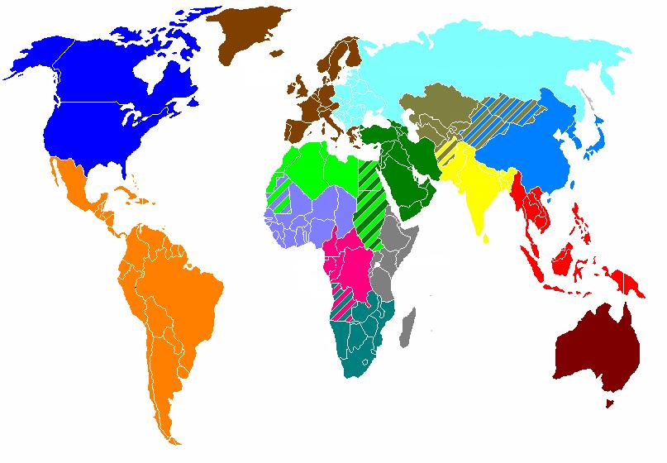

Colors and Tips | Region Name | Five Countries within Region
1. Royal Blue
2. Orange
3. Brown
4. Light Green
5. Lavender (Light Purple)
6. Pink
7. Teal (greyish-green, South)
8. Grey
9. Dark, Forest Green
10. Very light blue (North)
11. Moss Green (above yellow)
12. Yellow
13. Blue
14. Red
15. Maroon

