https://drive.google.com/file/d/0B7wlBJYcgLoiTmJURzVQOU56anc/view The Code of Hammurabi

Prologue
When the lofty Anil, king •of the Anunaki, and Enlil, lord of heaven and earth, who determines the destinies of the land, committed the rule of all mankind to Marduk, the first-bom son of Ea, and made him great among the Igigi; When they pronounced
10 the lofty name of Babylon, made it great among the quarters of the world and in its midst established for him an everlasting kingdom whose foundations were firm as heaven and earth--at that time Anu and Enlil named me Hammurabi, the exalted prince, the worshipper of the gods, to cause righteousness to prevail in the land, to destroy the wicked and the evil, to prevent the strong from plundering the weak, to go forth, like the sun over the black-headed race, to enlighten the land and to further the welfare of the people
The ancient seed of royalty, the powerful king, the sun of Babylon, who caused light to go forth over the lands of Sumer and Akkad', the king who caused the four quarters of the world to render obedience; the favorite of Innanna am I. When Marduk sent me to rule the people and to bring help to the land, I established law and justice in the language of the land and promoted the welfare of the people.
11

The Laws
- If a fire breakout in a man's house and a man who goes to extinguish it cast his eye on the household property of the owner of the house, and take the household property of the owner of the house, that man shall be thrown into the fire.
- If either an officer or a constable who is ordered to go on an errand of the king do not go . . . that officer or constable shall be put to death
42. If a man rent a field for cultivation and do not produce any grain in the field, because he has not performed the necessary work on^{s} the field they shall convict him, and he shall give to the owner of the field grain on the basis of the adjacent fields.
87. If he put out money at interest, for one shekel of silver he shall receive onefifth of a shekel as interest.
128. If a man take a wife and do not draw up a contract with her, that woman is not a wife.
150. If a man make his wife a present of field, garden, house, and goods and

deliver to her a sealed deed, after the death of her husband, her children may 12 not make any claim to her. The mother after her death may give them to her child who she loves, but to a brother she may not give them.
168. If a man set his face to disinherit his son and say to the judges, "I will disinherit my son," the judges shall inquire into his past, and if the son have not committed a crime sufficiently grave to cut him off from sonship, the father may not cut off his son from sonship.
- If a man destroy the eye of another man, they shall destroy his eye.
- If he break a man's bone, they shall break his bone.
- If he destroy the eye of a common man or break a bone of a common man, he shall pay one mina of silver.
- If he destroy the eye of a man's slave or break a bone of a man's slave, he shall pay one-half his price.
- If a man knock out a tooth of a man of his own rank, they shall knock out his tooth.
- If he knock out a tooth of a common man, he shall pay one-third mina of
silver.
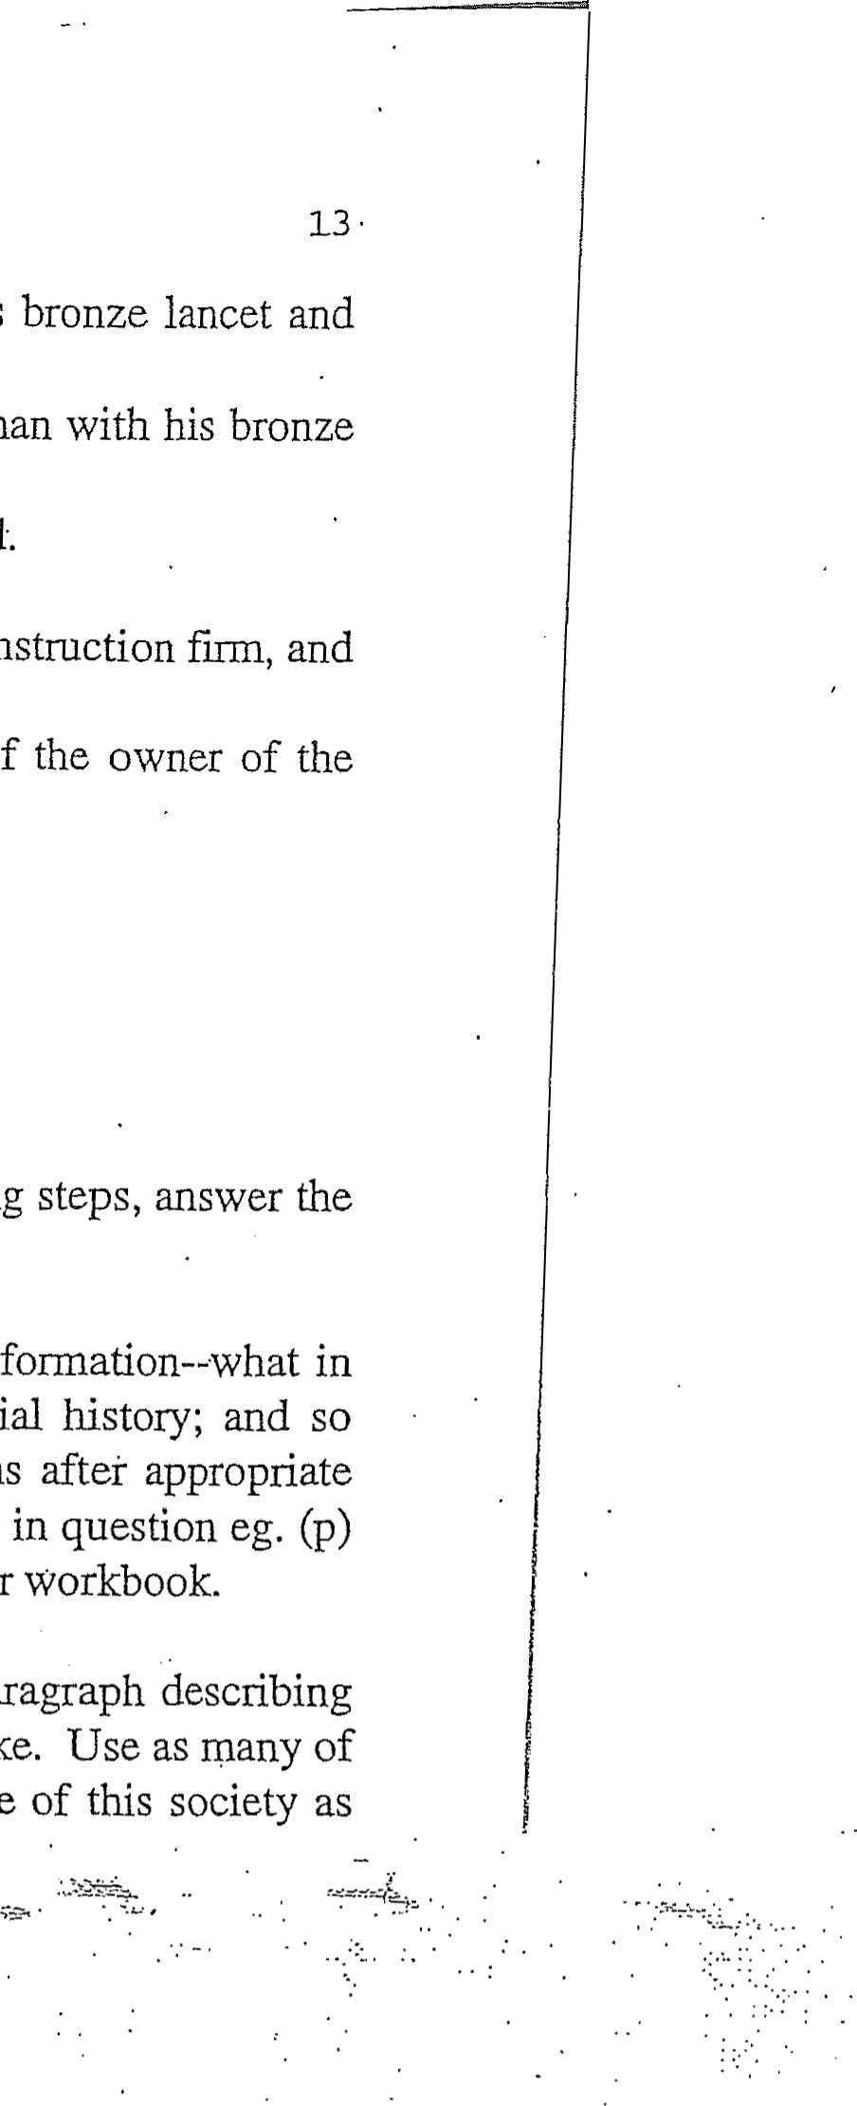
218. If a physician make a deep incision upon a man with his bronze lancet and cause the man's death, or operate on the eye socket of a man with his bronze lancet and destroy the man's eye, they shall cut off his hand.
229. If a builder erect a house for a man and do not make its construction film, the house which he built collapse and cause the death of the owner of house, that builder shall be put to death.(4)
QUESTIONS
Now that you have read the document and followed the preceding steps, answer the three questions below:
I. Apply the categories used by the historian to organize information—what in the document is political history; economic history; social history; and so forth. For purposes of simplification, place abbreviations after appropriate
• sentences or statements in the Prologue and after each law in question eg. (p) political, (soc) social, (sci) scientific. Write directly in your workbook.
2. Upon completion of your categorization, write a short paragraph describing what you believe life in Hammurabi's Mesopotamia was like. Use as many of the categories as you can to provide as complete a picture of this society as you can.

DOCUMENT
The Code of Hammurabi

Prologue
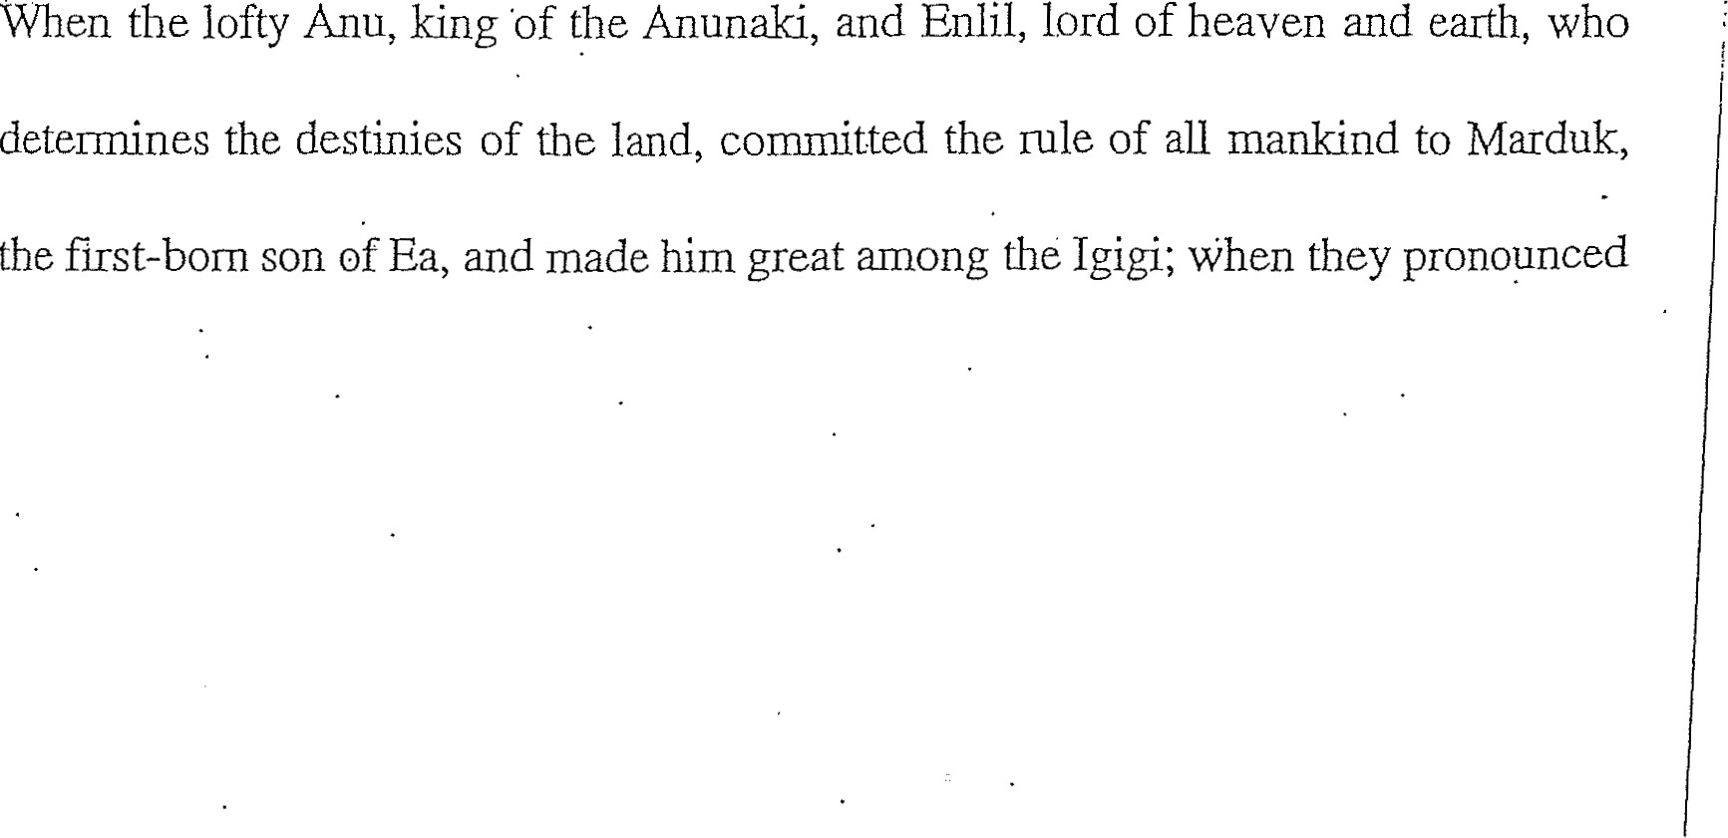

10 the lofty name of Babylon, made it great among the quarters of the world and in its midst established for him an everlasting kingdom whose foundations were fitm as heaven and earth--at that time Anu and Enlil named me Hamrnurabi, the exalted prince, the worshipper of the gods, to cause righteousness to prevail in the land, to destroy the wicked and the evil, to prevent the strong from plundering the weak, to go forth like the sun over the black-headed race, to enlighten the land and to further the welfare of the people .
The ancient seed of royalty, the powerful king, the sun of Babylon, who caused light to go forth over the lands of Sumer and Akkad; the king who caused the four quarters of the world to render obedience; the favorite of Innanna am I. When Mar-duk sent me to rule the people and to bring help to the land, I established law and justice in the language of the land and promoted the welfare of the people.

11

The Laws
- If a fire in a man's house and a man who goes to extinguish it cast
his eye on the household property of the owner of the house, and take the
household property of the owner of the house, that man shall be thrown into
the fire.
- If either an officer or a constable who is ordered to go on an errand of the
king do not go . . . that officer or constable shall be put to death
42. If a man rent a field for cultivation and do not produce any grain in the field,
because he has not performed the necessary work on• the field they shall
convict him, and he shall give to the owner of the field grain on the basis of
the adjacent fields.
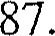If he put out money at interest, for one shekel of silver he shall receive one-
fifth of a shekel as interest.
128. If a man take a wife and do not draw up a contract with her, that woman is not
a wife.
150. If a man make his wife a present of field, garden, house, and goods and
deliver to her a sealed deed, after the death of her husband, her children may

12 not make any claim to her. The mother after her death may give them to her child who she loves, but to a brother she may not give them.
168. If a man set his face to disinherit his son and say to the judges, "1 will disinherit my son," the judges shall inquire into his past, and if the son have not committed a crime sufficiently grave to cut him off from sonship, the father may not cut off his son from sonship.
- If a man destroy the eye of another man, they shall destroy his eye.
- If he break a man's bone, they shall break his bone.
- If he destroy the eye of a common man or break a bone of a common man, he shall pay one mina of silver.
- If he destroy the eye of a man's slave or break a bone of a man's slave, he shall pay one-half his price.
- If a man knock out a tooth of a man of his own rank, they shall knock out his tooth.
- If he knock out a tooth of a common man, he shall pay one-third mina of
silver.

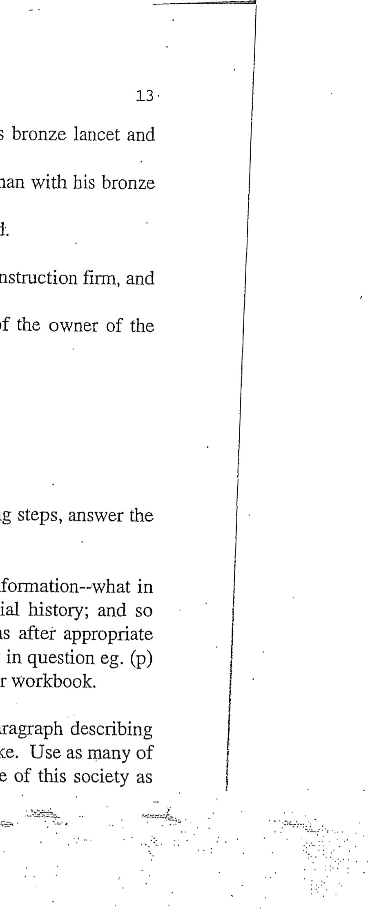
218. If a physician make a deep incision upon a man with his bronze lancet and cause the man's death, or operate on the eye socket of a man with his bronze lancet and destroy the man's eye, they shall cut off his hand.
229. If a builder erect a house for a man and do not make its construction firm, and the house which he built collapse and cause the death of the owner of house, that builder shall be put to death.(4)
QUESTIONS
Now that you have read the document and followed the preceding steps, answer the three questions below:
I. Apply the categories used by the historian to organize information—what in the document is political history; economic history; social history; and so forth. For purposes of simplification, place abbreviations after appropriate • sentences or statements in the Prologue and after each law in question eg. (p) political, (soc) social, (sci) scientific. Write directly in your workbook.
2. Upon completion of your categorization, write a short paragraph describing what you believe life in Hammurabi's Mesopotamia was like. Use as many of the categories as you can to provide complete a picture of this society you can.

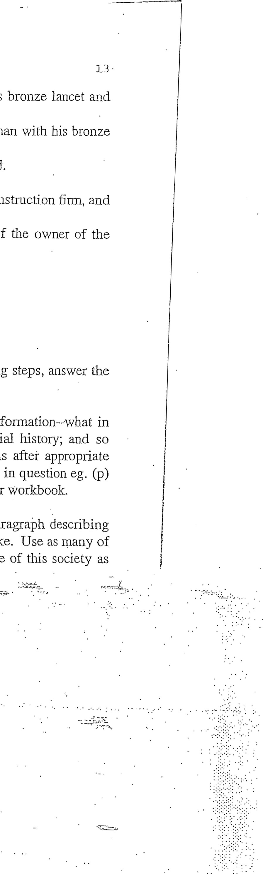
218. If a physician make a deep incision upon a man with his bronze lancet and cause the man's death, or operate on the eye socket of a man with his bronze lancet and destroy the man^{t}s eye, they shall cut off his hand.
229. If a builder erect a house for a man and do not make its construction finn, and the house -which he built collapse and cause the death of the owner of house, that builder shall be put to death. (4)
QUESTIONS
Now that you have read the document and followed the preceding steps, answer the three questions below:
I. Apply the categories used by the historian to organize information--what in the document is political history; economic history; social history; and so forth. For purposes of simplification, place abbreviations after appropriate • sentences or statements in the Prologue and after each law in question eg. (p) political, (soc) social, (sci) scientific. Write directly in your workbook.
2. Upon completion of your categorization, write a short paragraph describing what you believe life in Hammurabi^{t}s Mesopotamia was like. Use as many of the categories as you can to provide as complete a picture of this society as you can.

